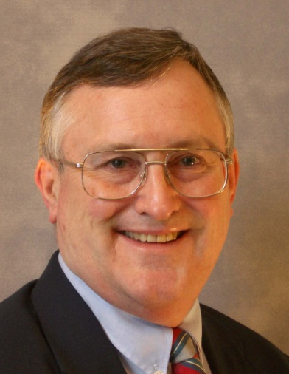

|  |  |
| --- | --- |
| **April 20, 2018 1:00-4:00PM** | **Montgomery County Memorial Library Central**  **104 I-45 N**  **Conroe, TX 77301**  **936-539-7814** |
| **FREE and Open to the Public** | |
| 3.0 Hours CEU Credit available. MCLE pending | |
| Space limited - **Register by April 13th** to reserve your seat | |
| [Amber.gong@mctx.org](mailto:Amber.gong@mctx.org) or 936-760-6914+3 | |

*“NVC provides us with the most effective tools to foster health and relationships.”*

Deepak Chopra, author of *The Seven Spiritual Laws of Success*

Discover the power of empathic connection.

Learn a simple, 4-part empathy process to transform anger and criticism into compassion for ourselves and others.

**Based on Nonviolent Communication (NVC)**

by Marshall Rosenberg, Ph.D (www.cnvc.org)

Sponsored by

The Dispute Resolution Center of Montgomery County, Inc.

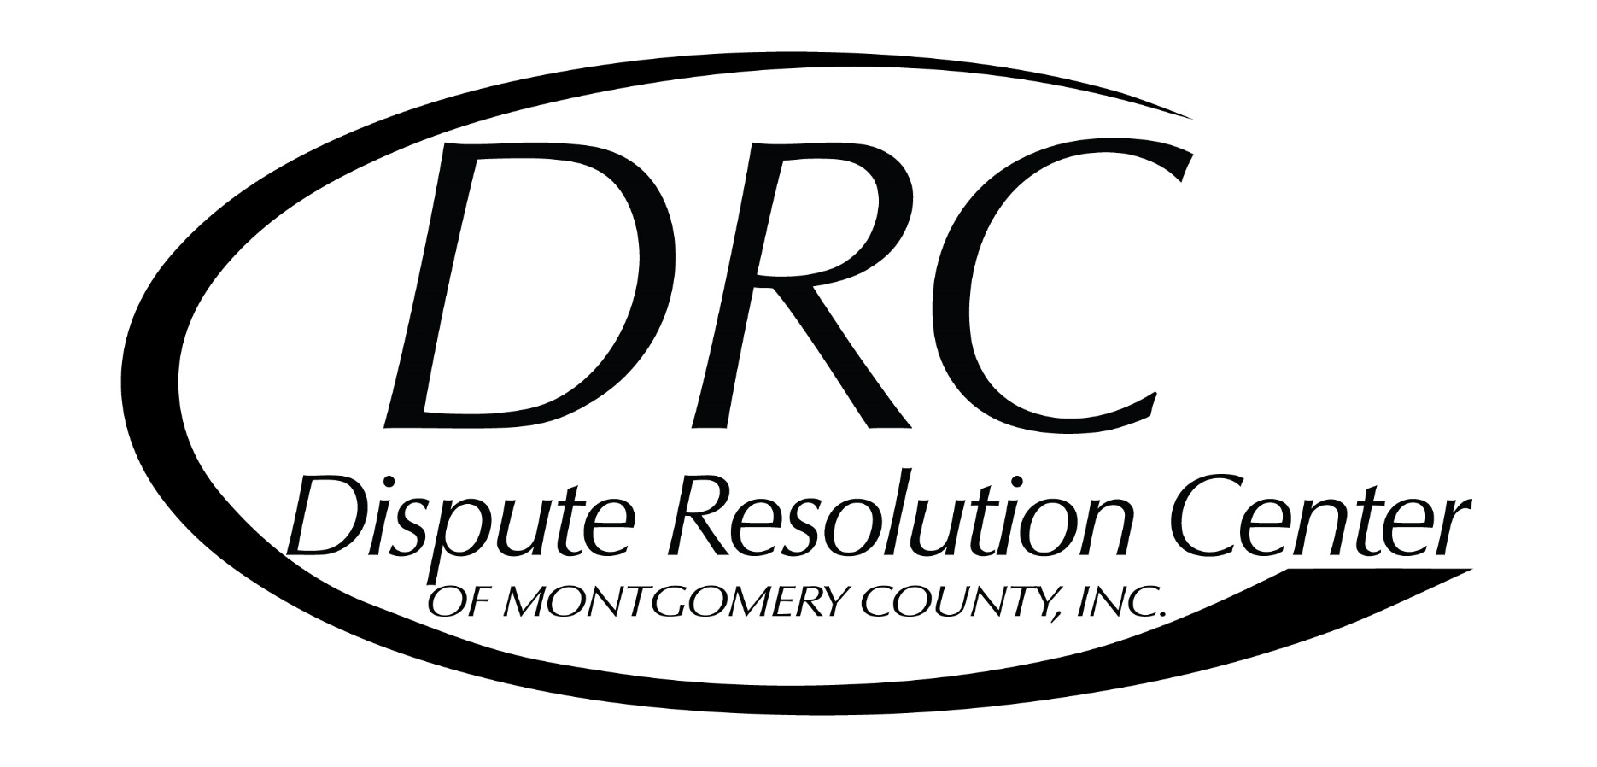

Helping people with difficult conversations since 1988.

www.resolution-center.org

Empathy Power

Led by

J. Lynn McDonald

www.power-with.com